***MID TERM REPORT OF***

**SIGN LANGUAGE RECOGNITION SYSTEM BASED ON COMPUTER VISION**

*A Graduate Project Report submitted to Manipal University in partial fulfilment of the requirement for the award of the degree of*

**BACHELOR OF TECHNOLOGY**

**In**

**Electronics and Communication Engineering**

*Submitted by*

|  |  |  |
| --- | --- | --- |
| **Suraj Pai**  Reg. No:120907042  Section: C  Roll No.: 9 | **Deepthi Varambally**  Reg. No:120907580  Section: C  Roll No.: 45 | **Pritika Kohli**  Reg. No:120907558  Section: C  Roll No.: 43 |

*Under the guidance of*

**Prof T.K. PadmaShri (Internal)**

**Associate Professor- Senior Scale**

**Department of Electronics and Communication**

**DEPARTMENT OF ELECTRONICS AND COMMUNICATION ENGINEERING**

**MANIPAL INSTITUTE OF TECHNOLOGY**

(A Constituent College of Manipal University)

MANIPAL – 576104, KARNATAKA, INDIA

**MAY 2016**

**ACKNOWLEDGEMENT**

We take this opportunity to express my sincere and deep sense of gratitude to my esteemed mentor Dr. T.K Padmashri for her guidance and support without which this task would not have been accomplished. We would like to thank our department who were part of this and their constant and timely help, moral support and valuable suggestions over the course of this project. We also thank my friends, who have helped me during this study. In addition ee thank one and all who have been instrumental in helping me complete this project.

**ABSTRACT**

Indian Sign Language (ISL) is a visuospatial language involving the use of hands, arms, facial expressions, and head/body postures to encode linguistic information. 98% of the deaf community in India is ISL illiterate and rely on inconsistent oralist methods of education. The advent of Science and Technology has been highly successful in aiding the design of solutions to emerging world problems. Our proposed work aims to employ available technology with at recognizing 3D dynamic signs, both local and global features for recognition making it a fine-grain description of a gesture. A variety of hand contours, finger orientations and trajectory information are made tractable with the advent of 3D sensors like Microsoft Kinect Technology. Our novel method classifies 2-4 gestures using Kinect for Windows (Global Feature Extraction) and 2 gestures using RGB Camera for Local Feature Extraction.

This project has implemented several methods for an optimal classification namely with an initial collection of varying training data sets over 3 features. Further, for feature extraction, binarization and normalization of the joint co-ordinates obtained from the skeletal images of the captured gesture, statistical parameters such as mean, variance, kurtosis and skewness achieved from the co-ordinates, and the joint values are all separately fed into a network classifier following a common neural network training method of error back propagation with several revised alternatives such as gradient descent, moment, scaled conjugate etc.

From the above described methods, the varying inputs fed into a network classifier using EBPTA, sensitivity and specificity results are obtained. They show diversified degrees of misclassification and classification. They are held in comparison to carry out the validation and testing procedures. The experimental result shows average of accuracy ‘ ‘ is high performance and feasibility for proposed method.

< Please insert the results followed up after the validation and testing processes> For gesture-image capturing, we used the Microsoft Kinect consisting of 3 cameras. For feature selection, normalization, neural network classifying and validation process, MATLAB simulation software has been used.

|  |  |  |  |  |  |
| --- | --- | --- | --- | --- | --- |
| **Contents** | | | | | |
|  | | | | | Page No |
| Abstract | | | |  | i |
|  | | | | | |
| **Chapter 1** | | | **INTRODUCTION** | |  |
|  | **1.1** | Introduction | | |  |
|  | **1.2** | Motivation | | |  |
|  | **1.3** | Organization of Report | | |  |
|  | | | | | |
| **Chapter 2** | | | BACKGROUND THEORY and/or LITERATURE REVIEW | |  |
|  | **2.1** |  | | |  |
|  | **2.2** |  | | |  |
|  | | | | | |
| **Chapter 3** | | | **METHODOLOGY** | |  |
|  | **3.1** |  | | |  |
|  | **3.2** |  | | |  |
|  | | | | | |
| **Chapter 4** | | | **RESULT ANALYSIS** | |  |
|  | **4.1** |  | | |  |
|  | **4.2** |  | | |  |
|  | | | | | |
| **Chapter 5** | | | **CONCLUSION AND FUTURE SCOPE** | |  |
|  | **5.1** | Work Conclusion | | |  |
|  | **5.2** | Future Scope of Work | | |  |
|  | | | | | |
| **REFERENCES** | | | | |  |
| **ANNEXURES (OPTIONAL)** | | | | |  |
| **PROJECT DETAILS** | | | | |  |

**CHAPTER 1**

**INTRODUCTION**

1. **Introduction**

This chapter describes the necessity of the project by highlighting a particular application of the Microsoft Kinect, neural networks and the objectives of our project.

Popular in XBOX gaming, **Kinect** is a hardware technology with software APIs that can interpret specific gestures, making completely hands-free control possible by using depth sensors, camera and a dedicated microchip to track the movement of objects and individuals in three dimensions. It is marvelous to see how this electronic motion controller (Kinect) can be extended in gesture recognition which serves as a great purpose for the deaf community. The approach revolves around acquiring precise gesture information from the Kinect sensors. The project aims at pre-processing, feature extraction and machine learning to classify various signs.

In the biomedical fields of advanced research, communication between normal and disabled person has been developed in several successful outcomes. However, speech processing and various other forms have been rapidly and extensively developed on, sign-language recognition in comparison, seems slightly lagging. Sign gestures are a non-verbal visual language, different from the spoken language, but serving the same function. Normal people generally enquire a translator to communicate with the hearing impaired. Recently research works on sign gestures have gained a lot of attention by many researchers in computer vision, pattern recognition and natural language.

Previously, some of the notable works involved glove based recognition. The ﬁrst category requires signers to wear a sensor glove or a coloured glove. The wearing of the glove simpliﬁes the task of segmentation during processing. Glove based methods suffer from drawbacks such as the signer has to wear the sensor hardware along with the glove during the operation of the system. In comparison, vision based systems use image processing algorithms to detect and track hand signs as well as facial expressions of the signer, which is easier to the signer without wearing gloves. The vision-based technique has seen innumerable approaches for recognition such as the conventional object –based video abstraction technique. Another technique involves the Hidden Markov Model where states are defined with probabilistic theories and have developed an unsupervised approach to train a robust detector the presence of human hands within an image and classified the hand shape. One paper has described the usage of template matching with normalized cross-correlation along with two wrist bands to identify and extract the gesture. A couple of other papers address the wavelet transformation applied to gesture images for. Finger-Earth Mover’s Distance (FEMD) which is a novel shape distance metric was used in its gesture recognition process.

Though all the above algorithm techniques were suitable and achieved classification of about 70-99%, it involved a lot of background noise removal in the pre-processing stage or has proved to be cumbersome when the classification extended to an acquired data of heavy amounts.

In our method, we have used dynamic signs of ISL as inputs to the system. The gesture data acquisition is also done under several conditions such as speed of movement, distance from the sensor and light illumination. The gesture data undergoes pre-processing followed by feature extraction. Also, the use of Microsoft Kinect has given depth information of our hands hence improving the accuracy of recognition. The proposed method integrates both local as well as global information of the dynamic sign. For Recognition, methods that take into account both the global hand motion (joint indices and joint co-ordinates devoid of the palms) and local motion (joint indices and co-ordinates involving only the fingers and the wrist) are most effective. We came up with a novel approach which uses both the local and global features of a gesture for Recognition which involves several optimal techniques of classification.

Artificial Neural Network (ANN) provides alternative form of computing that attempts to mimic the functionality of the brain. A simple neural network model is developed for sign recognition using the features computed from the training data set. The Neural Network architecture has three layers consisting of an input layer, one hidden layer and an output layer. With sensitivity and specificity tests, it gives us the percentage of accuracy of classification ad misclassification which helps us further to determine validation and testing processes for the gestures.

**Motivation**

Sign language is a gestural code representing the surrounding spoken language with varied features. These sign languages are complex natural languages and a part of the Deaf culture at all levels. Sign languages have various variants across the world. Our motive is to facilitate ISL words and capture them on Kinect sensors, thereby recognizing the dynamic ISL gestures.

The approach uses both local and global features for recognition making it a fine-grain description of a gesture. A variety of hand contours, finger orientations and trajectory information are made tractable. This system finds a variety of applications in:

* A brilliant application in the field of Computer Vision
* Widely used in Schools, Hospitals and Government agencies as a language interpreter
* An important tool in professional courses and associate programmes/degrees on Sign language.
* Sign language recognition systems are used in significant events like presidential speeches, courtroom affairs and office-work/conferences.

1. **Objective**

Classify 2-4 gestures using Kinect for Windows (Global Feature Extraction) and 2 gestures using RGB Camera for Local Feature Extraction

1. **Project Schedule**

|  |  |
| --- | --- |
| *January 2015* | * Collection of training data * Feature extraction for obtaining Global Features * Variation of subsequent data sets and data accumulation * Logging of methods and procedures used |
| *February 2015* | * Algorithm implementation for obtaining final input data to feed to the network * Design of the neural network (EBPTA) for classification. * Comparison of different algorithms with EBPTA for better classification results. |
| *March 2015* | * Experimentation with Neural Networks to identify best network for classification. * Variation of training data along with activation function to obtain best specificity and sensitivity results. |
| *April 2015* | * Finalization of neural network to be used and optimization processes. * Design of Local feature extraction method. |
| *May 2015* | * Local feature extraction method continuation * Documentation process. |

**1.3 Organisation of Report**

Chapter 1 introduces the application of the Microsoft Kinect to sign language recognition in the domain of computer vision . Chapter 2 describes the basics of image acquisition and relevant survey conducted in this field regarding the awareness and general statistics of physical features of the general population. It discusses the basic algorithm of pre-processing and neural networks. Chapter 3 describes the method incorporated for our project. It explains about the Binarization, Statistical analysis of gesture data incorporated with error back propagation and its different techniques. Chapter 4 deals with the result analysis by comparing the different techniques of classification. Chapter 5 is the conclusion of the result by comparing the different techniques of gesture classification.

**CHAPTER 2**

**BACKGROUND THEORY**

**Introduction**

Sign language is a visual language used by the deaf community constituting of two actions namely signs and finger spellings. Finger spellings categorize themselves into static postures defined by non-continuous hand motion whereas signs are identified as dynamic hand gestures characterized by continuous hand motion. Although there have been 2D approaches introduced earlier, 3D depth information technology is much more accurate and recognize a wider vocabulary of sign gestures. Our proposed work has been carried over 3 gesture lexicon with 200 variant data sets, followed by an ISL literacy survey in our campus. This chapter shall also introduce you to the theoretical concepts of error back propagation algorithm.

**Literature Review**

Kinect is a line of [motion sensing](https://en.wikipedia.org/wiki/Motion_sensing) [input devices](https://en.wikipedia.org/wiki/Input_device) by [Microsoft](https://en.wikipedia.org/wiki/Microsoft) for [Xbox 360](https://en.wikipedia.org/wiki/Xbox_360), a gaming device. Its sensors are based around a [webcam](https://en.wikipedia.org/wiki/Webcam)-style add-on [periphera](https://en.wikipedia.org/wiki/Peripheral)ls with a natural user interface for using gestures and spoken commands. Kinect is a hands free electronic device which built as a horizontal bar with a small base fitted with a tilt motor for rotational movement. The device features an RGB Camera, depth sensor and a microphone array and contains a special microchip to track the movement of individuals in three dimensions such as face, voice and motion capture abilities.[1] The Kinect also allows a feature extraction of about 6 people and 20 skeletal joints per each person tracked making it 20*6 joints during steady motion analysis.

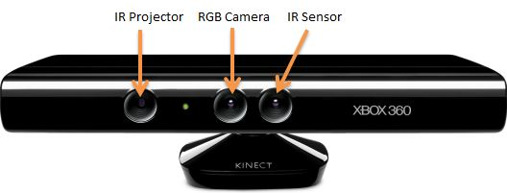

**[1] Microsoft Kinect**

The IR emitter/projector radiates pattern of infrared light which hits the surface of the object and forms a distorted image which is detected by depth camera and analyses and creates a 3D map of the room and objects in it. The RGB camera captures the video image. The sensor has an [angular field of view](https://en.wikipedia.org/wiki/Angle_of_view) of 57[°](https://en.wikipedia.org/wiki/Degree_(angle)) horizontally and 43° vertically, while the motorized pivot is capable of [tilting](https://en.wikipedia.org/wiki/Tilt_(camera)) the sensor up to 27° either up or down. The RGB camera can also resolute the image in two forms – 640x480 and 1280x1024 pixels. There is a USB port enabling it to transfer data via an unencrypted feed.

Our next step was dealt with data acquisition required for training. Our prime focus was on 3 gestures which focused more on the global features namely – ‘Hello’, Good Morning’, and ‘Good’. For starters, we collected varied training data sets from 3 people under 3 varying conditions such as lighting conditions, obstacles in between and gesture speed variation making it database of 108. 12 variant per person per gesture was captured making it a contribution of 36 variants in total per person. The distance conditions involved gesture capturing from the sensor at distance of 1.5m, 2m and 2.5m. For each distance, 4 variants were considered. For lighting conditions, for every distance index, one image has been taken with a contrasting lighting as compared to the other three. This, making it a total of 54 contrasting images. Images have been randomized with obstacles in between for variance and for each gesture speed; it has been recorded with indices for generalization purposes.

In contrast to arbitrarily choosing frames for motion capture, an algorithm is used to detect when the motion begins and thereby assigning the 3 frames. For eg: If motion is detected at the 120th frame, the f1=120,f2=160 and f3=200. This is done by giving a simple increment from the motion detected frame. Also note, hereby all the gesture images are captured over three frames. The images are further led to binarization and normalization for generalization purposes and are their corresponding black and white RGB values are fed into the excel sheet as binary 0 or 1 for better classification purposes which will be explained briefly in the upcoming chapter.

<*insert skeletal image of gesture over 3 frames with excel sheet values*>

A survey was conducted in the Food Court of the MIT premises as a part of our project, to collect gestural information with better variants for our training data which will lead to increased efficiency in training. We also managed to create awareness and knowledge amongst the student population about ISL, sign language barrier problems and our project as a solution to it. We had a small quiz created via type-form which gave us a moderate result about ISL literacy within our campus. We also managed to collect hyper-local statistics of students such as weight, height, age, gender which would further help us to correlate our gestural information on this basis. About 100 data sets from our survey were obtained forming around a pool 200 variants which would further be fed into our network for classification.

<*insert typeform image and results*>

The workhorse of our neural network classification is dealt by the **error back propagation theorem.** Method of training artificial neural networks which calculates the gradient of a loss function with respect to all the weights in the network and is fed to the optimization method which in turn uses it to update the weights to minimize the loss function.

The **demon[1]** sits at the jth neuron in layer ’L’. As the input to the neuron comes in, the demon messes with the neuron's operation. It adds a little change  to  the neuron's weighted input, so that instead of outputting ,    the neuron instead outputs          . . This change propagates through later layers in the network.

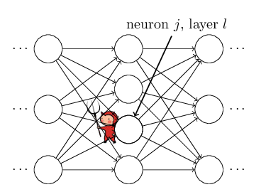

The following flowchart gives the entire description of the working of the lgorithm.

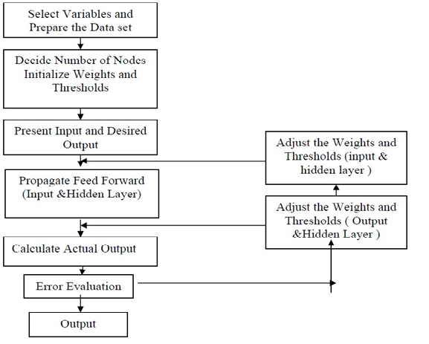

Important definitions and parameters of EBPTA:

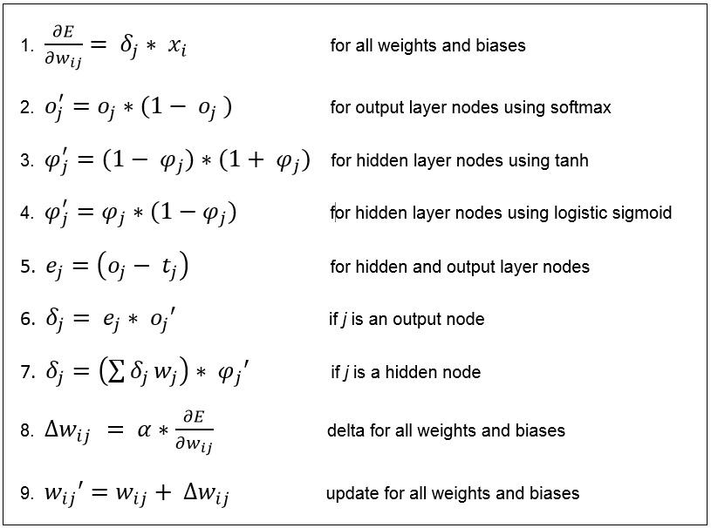

**CHAPTER 3**

**METHODOLOGY**

This chapter will explain about the Binarization, Statistical analysis of gesture data incorporated with error back propagation and its different techniques.

**Introduction**

The flow of the entire process for gesture recognition is represented by our diagram[4]

The Kinect is connected to the PC and powered up with plugin source. The object of focus, let us say, the person whose gesture is to be tracked should be placed in front of the sensor. The gestural motion is captured over three frames as a 640x480 image. This is the first first prototype and we lead it to binarizing the image. Binary image is nothing but the digital form of an image where all the pixel values are representing as either 0 or 1. This is also called as bi-level image since the pixel values take either of the single-bit values. Zero represents black and white represents 1. Also note, the Kinect can recognize over20 joints of the human skeletal figure. However, we dealt with our settings to capture the joints of only the upper torso and excluding the finger joints making it an overall of 10 joints and a global feature.

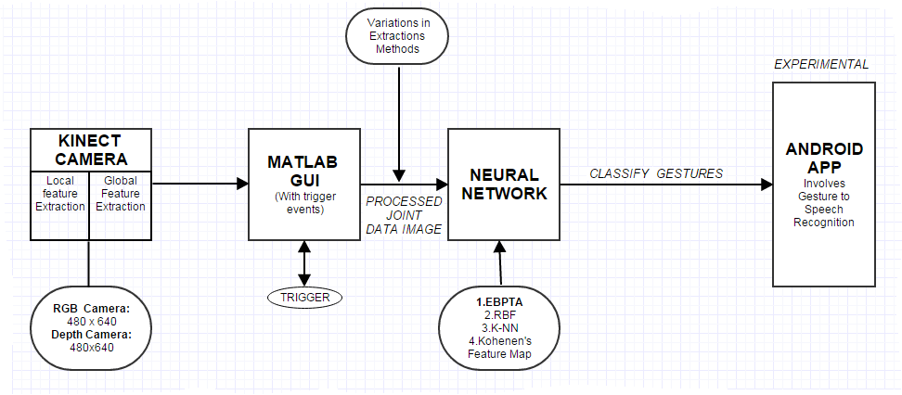

**FLOW DIAGRAM**

This is further normalized by drawing a rectangle box around the captured skeletal image to delete the redundant white background and also uniformize the non-uniformity and alter the range of the pixel intensity values for generalization purposes. The first prototype is reduced to a 256x256 image which contain about 16 blocks of 4096 elements which are then separately fed into the network. Also, semantics of each co-ordinate is displayed for clear depiction of the movement. The normalized images of the same gesture over three different variants are shown below[3]

**<***insert the image of normalised gestures***>**

Using a variety of training methods for error back propagation and hidden layer configurations to observe effect on network performance is seen. The mean squared error i.e the performance function, hidden neurons and supporting parameters are variably adjusted to confer onto results. The program is set for a confusion plot acquired from the neural network tool box of the MATLAB which gives a matrix of target class against the output class. The diagonal cells represents correctly predicted and the rightly classified percentage and the off diagonal elements represent the misclassification individually. The cell in the bottom right represents the overall accuracy of the classification.

The training functions used with binarised input values are

1. ***traingd*** : The weights and biases are updated in the direction of the negative

gradient of the performance function.

***2. traingdm***: Same as the ‘traing’ buthas an additional feature of momentum.

Functions acts like a lowpass filter, momentum allows the network to ignore small

features in the error surface.

***3. traingdx:*** The function traingdx combines adaptive learning rate with

momentum training.

***4. trainlm:*** Updates weight and bias values according to Levenberg-Marquardt

optimization. This function uses the Jacobian for calculations, which assumes that

performance is a mean or sum of squared errors.

***5. trainscg:*** this training function is comparison of the convergence of gradient

descent in iterations conjugate vector (direction) to obtain a solution to linear

system.

<*insert images and performance values of each and also state which is the best and state it again the results column*>

*Statistical Analysis:* This involves image analysis on 2D images which is subjected to statistical interrogation for comparative. The processed image is in the form of an array of cells or a Matlab matrix which computes the distance between the individual values which helps us obtain the statistical parameters such as mean, variance, kurtosis and skewness distribution parameters. The difference between these parameters in 3D for 10 joints over 3 gestures is plotted. With the results from this, we use the mean of the individual gestures and obtain the other central moment parameters in terms of this.

i.e if Mean = M, Input = X

Variance = (X-M)2

Kurtosis = (X-M)3

Skewness = (X-M)4

## These parameters are fed into the neural with back propagation using different training methods as described earlier. Joints 1,2,3,7,8 that had mean values for all 3 gestures lying close to each other were taken( approximate difference of 0.1-0.3 in all three dimensions.)

## These joints had a high difference in skewness and kurtosis measures. (Approximately 1.5-4 in all three dimensions). The difference in values were used as a classification feature.

## *5 joints x 3 dimensions x 3 gestures= 45 element vector x 4 central moment measures= 180 feature vectors*.

## Data that was redundant was eliminated and coordinates that could help identify the gestures better were given more priority and more features were derived

<insert relevant table>

## Joint Co-ordinates: They are simply taken as the features and fed into the network. All the 10 joints in 3 dimensions are taken as features for the neural network. 120 samples are taken for each.

## <insert relevant plot and table>

**Tools Used:**

MATLAB:

In this project we use MATLAB – vR2014a. Here, MATLAB is used to generate the normalized images and neural networking classification. Also we use MATLAB to convert the testing and validation purposes.

The MATLAB platform is optimized for solving engineering and scientific problems. The matrix-based MATLAB language is the world’s most natural way to express computational mathematics. Built-in graphics make it easy to visualize and gain insights from data. A vast library of prebuilt toolboxes lets you get started right away with algorithms essential to your domain. The desktop environment invites experimentation, exploration, and discovery. These MATLAB tools and capabilities are all rigorously tested and designed to work together. The key features of MATLAB are:

* High-level language for scientific and engineering computing.
* Desktop environment tuned for iterative exploration, design, and problem-solving.
* Graphics for visualizing data and tools for creating custom plots.
* Apps for curve fitting, data classification, signal analysis, and many other domain-specific tasks.
* Add-on toolboxes for a wide range of engineering and scientific applications.
* Tools for building applications with custom user interfaces.
* Interfaces to C/C++, Java, .NET, Python, SQL, Hadoop, and Microsoft Excel.
* Royalty-free deployment options for sharing MATLAB programs with end users.

**CHAPTER 4**

**RESULT ANALYSIS**

This chapter should include

* Introduction (1 paragraph brief of what is going to be discussed in this chapter)
* Result analysis
* Graphical / tabular form
* Explanation for the graphical / tabulated results
* Significance of the result obtained
* Any deviations from the expected results & its justification
* Conclusions

**CHAPTER 5**

**CONCLUSION AND FUTURE SCOPE OF WORK**

This chapter should include

* Brief summary of the work
* Problem statement / objective, in brief
* Work methodology adopted, in brief
* Conclusions
* General conclusions
* Significance of the results obtained
* Future scope of work.

(At least three paragraphs, one for each suggestion has to be written.)

**REFERENCES**

*Journal / Conference Papers*

[1] Name 1 and Name 2, “Paper Title”, Full Journal Name, volume no, publication year, page numbers

[2] Name 1 and Name 2, “Paper Title”, Proceedings of the International / National Conference on ___, Institution, Country, Date, page numbers

1. Paulraj MP, Saazali Yacob, Hazry Desa, "*Extraction of Head and Hand Gesture Features for Recognition of Sign Language*", 2008 International Conference on Electronic Design.
2. Geetha M, Manjusha S, “*A Vision Based Dynamic Gesture Recognition of Indian Sign Language on Kinect based Depth Images*”
3. Boreki, Zimmer, “*HAND GEOMETRY: A NEW APPROACH FOR FEATURE EXTRACTION*”

*Reference / Hand Books*

[1] Name 1, “Book Title”, Publication Name, Edition, ISBN number

*Web*

[1] Topic 1, website name (do not include long URL’s)

This chapter should include

* Introduction (1 paragraph brief of what is going to be discussed in this chapter)
* Methodology
* Detailed methodology
* Assumptions made
* Circuit layout / one-line / block diagrams
* Component specifications
* Justification for component selection
* Tools used
* Detailed specification / listing of the various components, measuring devices, software tool boxes, reference data sheets etc
* Preliminary result analysis if any
* Conclusions

**ANNEXURES (optional)**

Annexure to include

* Product Data sheets
* Design drawings
* Standard diagrams
* Lengthy codes / algorithms etc

PROJECT DETAILS

|  |  |  |  |
| --- | --- | --- | --- |
| *Student Details* | | | |
| **Student Name** |  | | |
| Register Number |  | Section / Roll No |  |
| Email Address |  | Phone No (M) |  |
| **Student Name** |  | | |
| Register Number |  | Section / Roll No |  |
| Email Address |  | Phone No (M) |  |
|  | | | |
| *Project Details* | | | |
| **Project Title** |  | | |
| Project Duration |  | Date of reporting |  |
| Expected date of completion of project |  |  |  |
|  |  | | |
| *Organization Details* | | | |
| **Organization Name** |  | | |
| Full postal address with pin code |  | | |
| Website address |  | | |
|  |  | | |
| *Supervisor Details* | | | |
| **Supervisor Name** |  | | |
| Designation |  | | |
| Full contact address with pin code |  | | |
| Email address |  | Phone No (M) |  |
|  |  | | |
| *Internal Guide Details* | | | |
| **Faculty Name** |  | | |
| Full contact address with pin code | Dept. of E&C Engg., Manipal Institute of Technology, Manipal – 576 104 (Karnataka State), INDIA | | |
| Email address |  | | |
| *Co- Guide Details(if any)* | | | |
| **Faculty Name** |  | | |
| Full contact address with pin code | Dept. of E&C Engg., Manipal Institute of Technology, Manipal – 576 104 (Karnataka State), INDIA | | |
| Email address |  | | |

**General Guidelines (Delete this page when making the report submission)**

* Project Report to be minimum 18 pages. Reports less than 18 pages will be rejected
* Project report to be maximum 20 - 30 pages (preferred)
* Paper Size: A4; Left = Right = Top = Bottom Margins = 1”
* Page Numbering Position: Bottom with right justified and continuous numbering from the Introduction Chapter
* Use Times New Roman Font with Normal Style, paragraph justified and 1.25 line spacing
* Paragraph Heading: Times New Roman Font, Bold, Font Size 14; Paragraph Matter: Times New Roman Font, Normal, Font Size 12;
* Sub-paragraphs be appropriately numbered as in 1.1, 1.2, 1.3 etc; Sub-paragraph Heading: Times New Roman Font, Italics, Font Size 12; Sub-paragraph Matter: Times New Roman Font, Normal, Font Size 12;
* Figure captions below Figure with chapter wise numbering
* Tables captions above Table with chapter wise numbering
* All references must be quoted in ascending order (follow IEEE format for referencing)
* Project Details page must be the last page in the project report
* Only Soft bound reports will be accepted. The outer cover of the report will be **PURE WHITE** with a 170 GSM paper.

* **Arrangement of contents**

[1] Cover page (same as inner page)

[2] Inner page

[3] Abstract

[4] Table of contents

[5] Chapters 1, 2, 3, 4, 5

[6] References (follow IEEE format)

[7] Annexures

[8] Project Details (Last page of the report)

* The above guidelines should be used only as a help guide and is more or less a standard way of report writing
* Report formatting should not be disturbed in any form
* **Project students are requested to discuss with their department guides regarding the contents of the project report**
* Hard Copies to be submitted: 1
* Soft copy (both word and pdf format) to be submitted to internal guide.